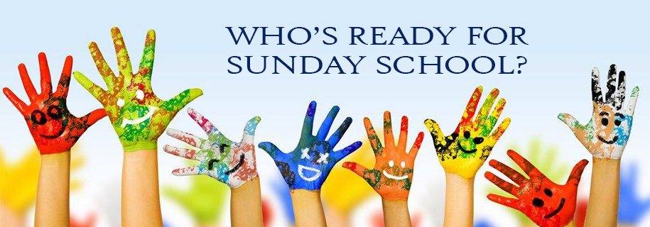

Please join us for Sunday School!
It’s every Sunday morning starting at 9:45 am. Birth-Adults
Teachers and literature are as follows:

Kindergarten:
Cindy Stephens and Seretha Pittman
Lifeway: Bible Studies For Life

1st-2nd Grade:
Penny Claiborne and Tina Sledge
Lifeway: Bible Studies For Life

3rd-4th Grade:
Wanda Matthews and Angie Nelson
Lifeway: Explore the Bible

5th Grade:
Sarah Taylor, Nikki Keeter, and Jennifer Clemmons
Lifeway: Explore the Bible

